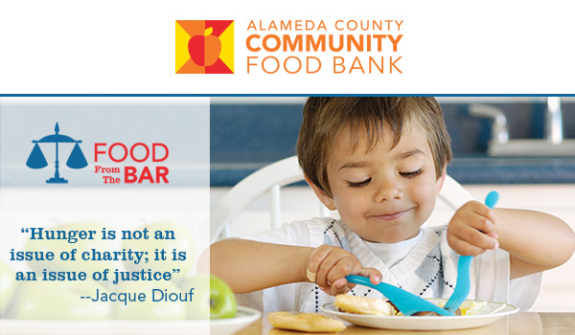
[PERSONALIZED GREETING].

I’d like to personally encourage your participation in something I’m passionately supporting. This year, I’m joining in Food From The Bar to raise 200,000 meals for local children and their families. We can’t meet that goal without you!

Alameda County Community Food Bank serves 1 in 4 county neighbors. Each year, they engage our legal community in Food From The Bar, a national campaign where law firms/legal departments support their local food banks in a friendly fundraising competition throughout the month of May.

Will you join the Food Bank this year to help provide 200,000 meals to children facing a meal gap? All proceeds go directly to the Food Bank’s efforts to fight summer hunger.

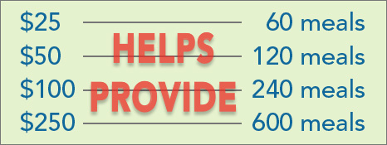

Participating is easy. You can donate here or visit ACCFB’s Food from the Bar website to sign up a team and join in the competition.

If you have any questions, please contact Katherine Avila, ACCFB Food & Fund Drive Coordinator.

Thank you for doing your part to overrule summer hunger!

Sincerely,

[NAME]
[TITLE]
[ORGANIZATION]

